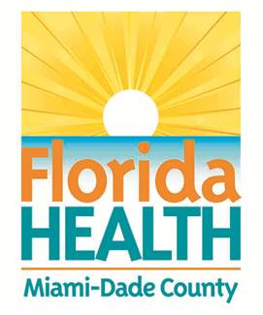
FLORIDA DEPARTMENT OF HEALTH IN MIAMI-DADE
SCHOOL HEALTH PROGRAM

ROLES AND RESPONSIBILITIES: SEVERE ALLERGIES

Student: ___________________________ DOB: _________ Teacher: _____________ Grade: _______

Parent/Guardian & Phone(s): ___________________________ School Year: __________________

SEVERE ALLERGY ACTION PLAN: Follow the attached physician action plan.
School Responsibilities/Agreements | Family Responsibilities/Agreements | Student Responsibilities/Agreements
- Epinephrine auto injector Kept:  Staff authorized to administer epinephrine auto injector (review plan, recognize symptoms and respond): | 1. Provide medication for school site/replace any expired medication. Exp. Date: ________ | 1. Report any signs/symptoms
- Staff to administer medications per MDCPS training: | 2.Keep school staff informed of any changes in student condition or medications | 2. Do not trade food with others
- Staff to contact 911/parent/guardian: | 3. Available to accompany student on field trip and carry the epinephrine auto injector (complete school volunteer form).  Alternate for parent/guardian (complete volunteer form): | 3. If applicable, carry epinephrine auto injector as directed by physician.
- Staff to direct EMS to the emergency | 4. (Severe Food Allergies) Provide all meals/snacks for student
- CPR certified staff: | 5. If applicable, check student is carrying epinephrine auto injector as directed by physician
- Prevention at school site:
School grounds: Control of insects
Contact MDCPS Safety, Environment, Hazards Management

Cafeteria: ___________ free table or clean table with single use paper towel with MDCPS approved cleanser.

Cafeteria Manager:

Teacher/paraprofessional to carry school
two- way radio
- Substitute teacher instructions:

________________________________ ___________________
Parent/Guardian Signature Date
________________________________ __________________
Principal or School Administration Designee Date
____________________________ _________________
School Nurse Date

